**Aggregate Report**

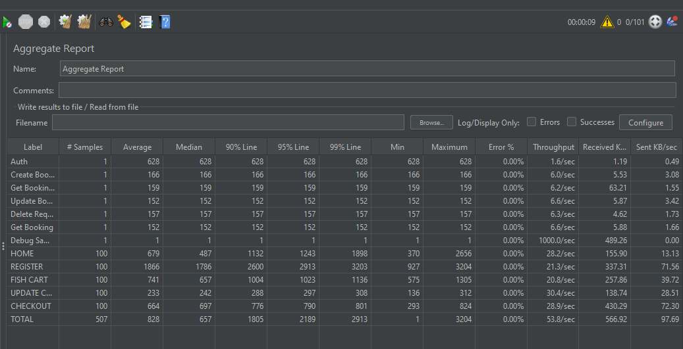

|  |  |
| --- | --- |
| **Service Level Agreement** | **Status** |
| Total Error not exceed **10%** Pass | Pass |
| 90% not exceed **3 seconds** | Pass |
| 99% not exceed **5 seconds** | Pass |